EXPERIMENT 3
Dimensional Modeling and Star Schema Design using Microsoft Power BI

Steps to Perform the Experiment:
Step 1: Open Power BI Desktop and import the Global Superstore Dataset.xlsx file using Get Data.
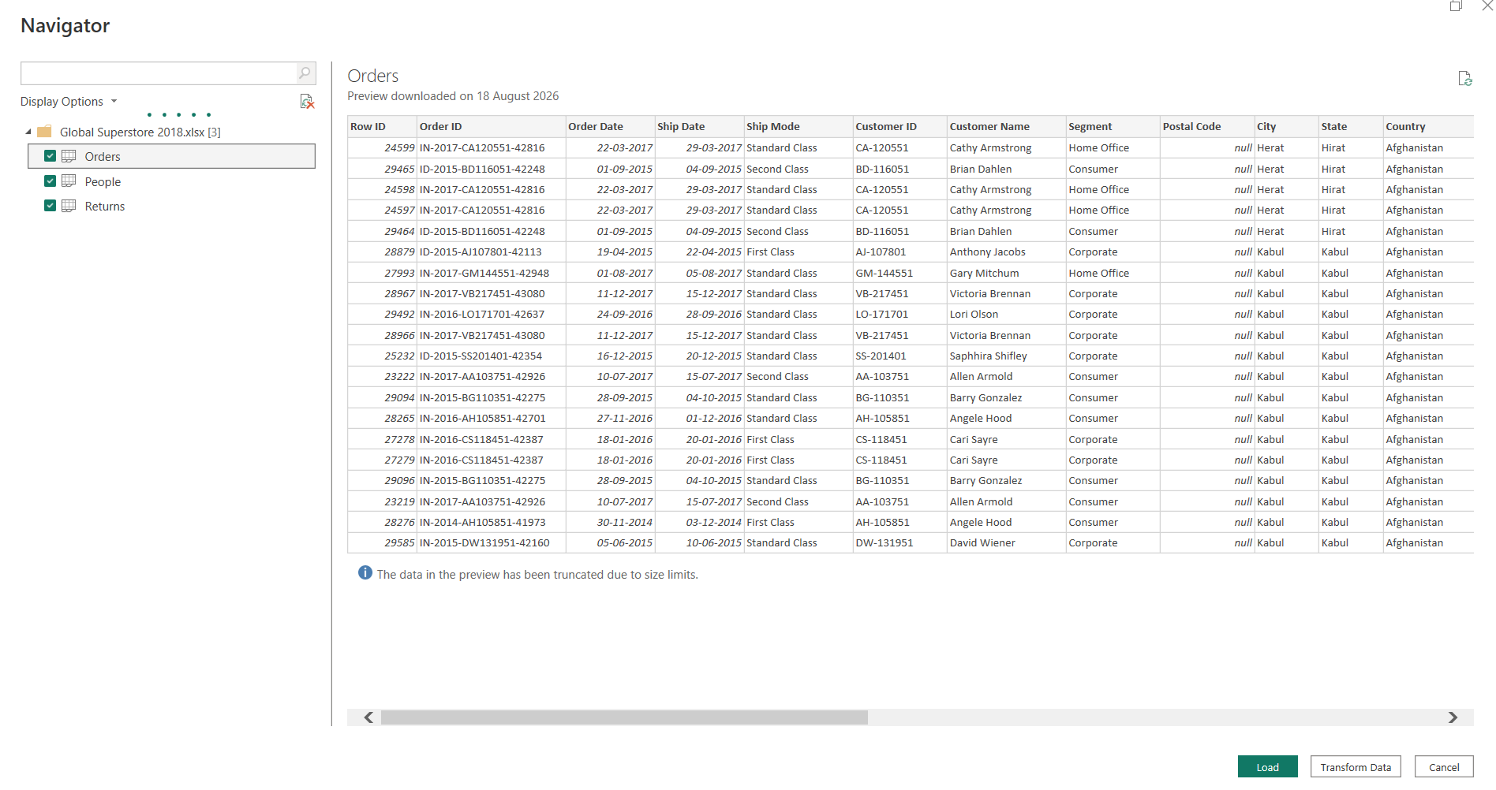
Step 2: Select the Orders, Returns, and People worksheets and click Transform.
Step 3: Analyze the Orders table and identify measurable values and descriptive attributes for the model.
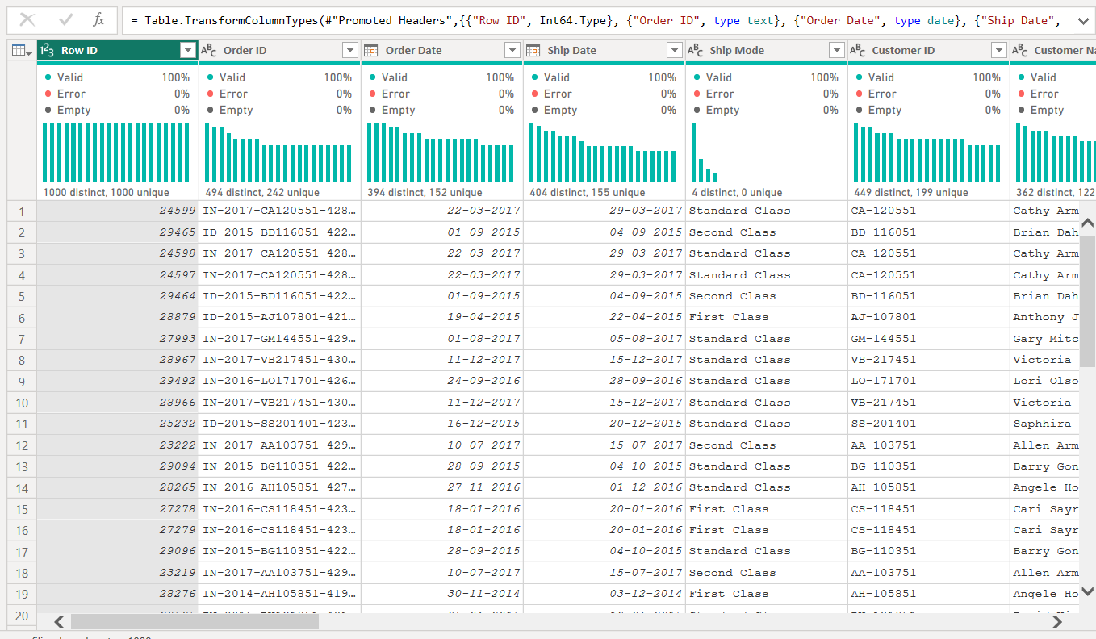
Step 4: Create Dim_Customer, Dim_Product, Dim_Region, and Dim_Date using the required attributes from the dataset.
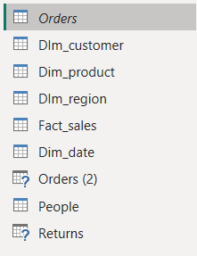

Step 5: Remove duplicate records from the Dimension tables and create the Fact_Sales table with the required columns and apply.
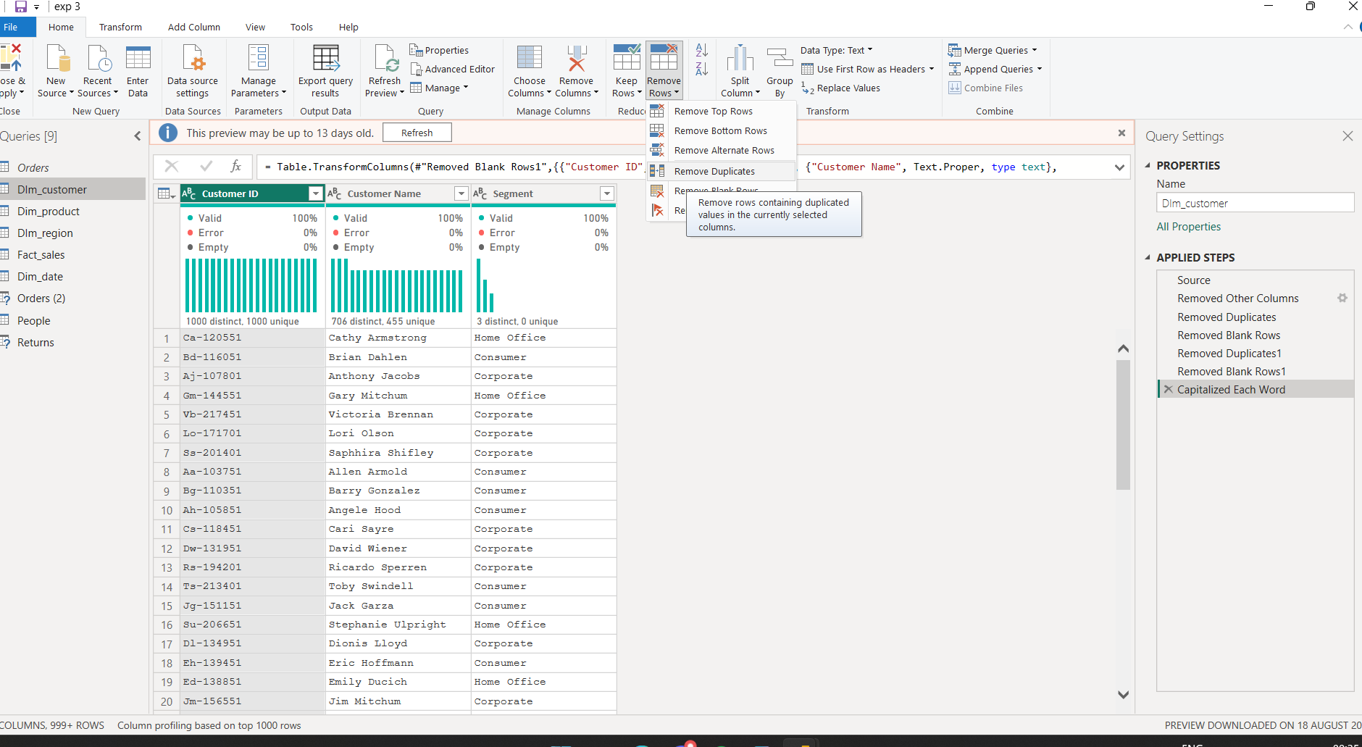

Step 6: Open Model View and create Many-to-One relationships between Fact_Sales and the Dimension tables.
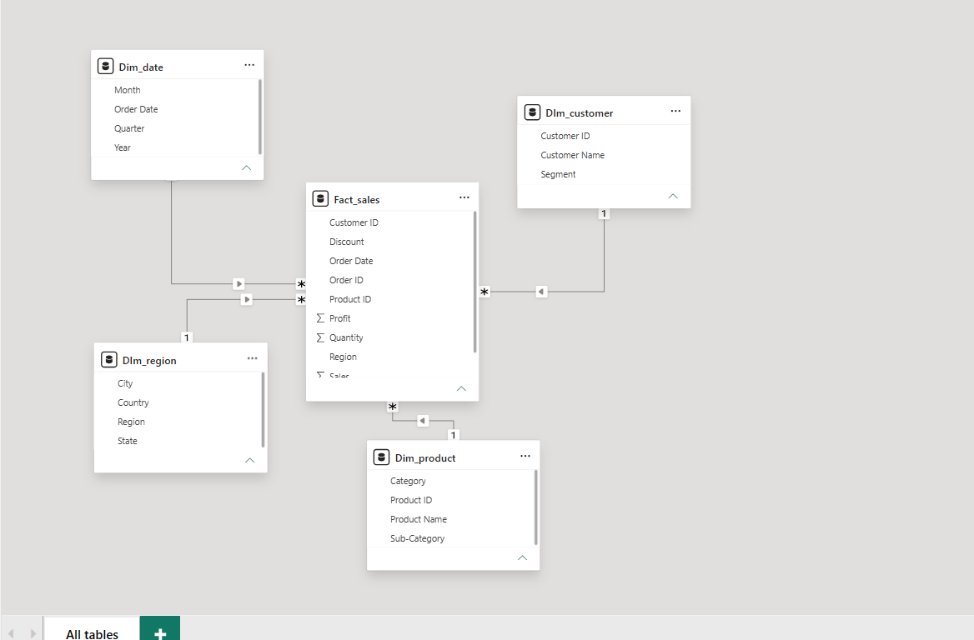

Step 7: Create Sales, Profit, and Sales Trend visualizations along with DAX measures such as Total Sales and Total Profit.
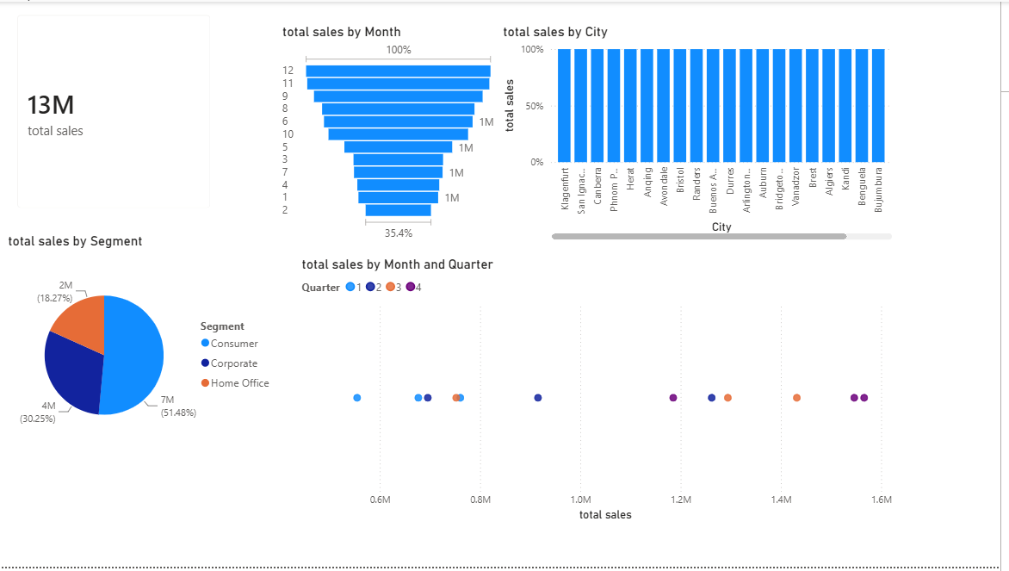
Learning Outcomes
- Understand the concepts of dimensional modeling and Star Schema architecture.
- Differentiate between Fact Tables and Dimension Tables.
- Design a dimensional model using a real-world business dataset.
- Create and validate relationships between Fact and Dimension tables in Power BI.
- Develop DAX measures for analytical reporting.

